Practical No. 1
Aim: Write a Python program to create a class with instance variables, class variables, instance methods, class methods, and static methods.

Theory:
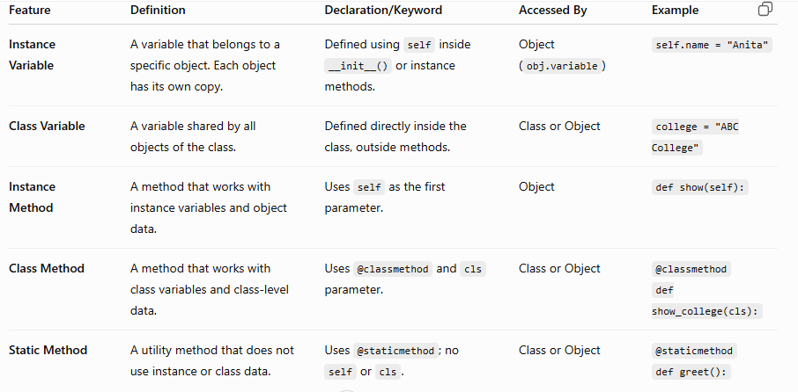

Code:

class Student:
college = "PHCASC" # Class variable

def __init__(self, name):
self.name = name # Instance variable

def show(self): # Instance method
print(self.name)

@classmethod
def show_college(cls): # Class method
print(cls.college)

@staticmethod
def greet(): # Static method
print("Welcome!")

s = Student("Anita")
s.show()
Student.show_college()
Student.greet()

Output:
Anita
PHCASC
Welcome!

Practical No.2
Aim: Develop a program demonstrating default constructor, parameterized constructor and destructor.

Theory:
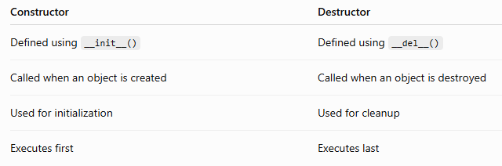

Code:

class Demo:
def __init__(self, name="Guest"): # Default & Parameterized Constructor
self.name = name
print("Constructor called:", self.name)

def __del__(self): # Destructor
print("Destructor called for:", self.name)

# Default Constructor
obj1 = Demo()

# Parameterized Constructor
obj2 = Demo("Anita")
del obj1
del obj2

Output:
Constructor called: Guest
Constructor called: Anita
Destructor called for: Guest
Destructor called for: Anita

Practical No-3
Aim: Create a base class and derived class to demonstrate inheritance and method overriding.
Source Code:
# Base Class
class Animal:
def sound(self):
print("Animal makes a sound")

# Derived Class
class Dog(Animal):
def sound(self): # Method Overriding
print("Dog barks")

# Creating Objects
a = Animal()
d = Dog()

# Calling Methods
a.sound()
d.sound()

Practical No-4
Aim: Design a simple student registration form using Tkinter with labels, textboxes, and buttons.

from tkinter import *

# Create window
root = Tk()
root.title("Student Form")

# Labels
Label(root, text="Name").pack()
Entry(root).pack()

Label(root, text="Roll No").pack()
Entry(root).pack()

# Buttons
Button(root, text="Submit").pack()
Button(root, text="Clear").pack()

# Run window
root.mainloop()

Practical No 5
Aim:Creating a Student Registration Form Using Tkinter.
Source code:
from tkinter import *
from tkinter import messagebox
# Function for Submit button
def submit():
messagebox.showinfo("Success", "Registration Successful!")
# Create window
root = Tk()
root.title("Student Registration Form")
root.geometry("300x200")
# Labels and Textboxes
Label(root, text="Name").pack()
Entry(root).pack()
Label(root, text="Roll No").pack()
Entry(root).pack()
Label(root, text="Course").pack()
Entry(root).pack()
# Buttons
Button(root, text="Submit", command=submit).pack()
Button(root, text="Clear").pack()
# Run window
root.mainloop()

Practical No-6
Aim: Create a database and perform Create, Read, Update, Delete operations using SQLite in Python
Source code:
import sqlite3

conn = sqlite3.connect("student.db")
cursor = conn.cursor()

cursor.execute("DROP TABLE IF EXISTS Student")

cursor.execute("""
CREATE TABLE Student(
RollNo INTEGER PRIMARY KEY,
Name TEXT,
Marks INTEGER
)
""")

# INSERT DATA (Create)
cursor.execute("INSERT INTO Student VALUES (1, 'Anita', 90)")
cursor.execute("INSERT INTO Student VALUES (2, 'Rahul', 85)")
conn.commit()

print("Records Inserted")

# READ DATA
print("\nStudent Records:")
cursor.execute("SELECT * FROM Student")
rows = cursor.fetchall()

for row in rows:
print(row)

# UPDATE DATA
cursor.execute("UPDATE Student SET Marks = 95 WHERE RollNo = 1")
conn.commit()

print("\nAfter Update:")
cursor.execute("SELECT * FROM Student")
rows = cursor.fetchall()

for row in rows:
print(row)

# DELETE DATA
cursor.execute("DELETE FROM Student WHERE RollNo = 2")
conn.commit()

print("\nAfter Delete:")
cursor.execute("SELECT * FROM Student")
rows = cursor.fetchall()

for row in rows:
print(row)

# Close connection
conn.commit()
conn.close()

Practical No-7
Aim: Develop a basic TCP server and client program using Python socket programming.

Step 1: Create TCP Server
Save as server.py
import socket

# Create socket
server = socket.socket(socket.AF_INET, socket.SOCK_STREAM)

# Bind IP and Port
server.bind(("localhost", 5000))

# Listen for client
server.listen(1)

print("Server is waiting for connection...")

# Accept connection
client_socket, address = server.accept()

print("Connected to:", address)

# Receive message
message = client_socket.recv(1024).decode()

print("Client:", message)

# Send reply
client_socket.send("Hello Client! Message Received.".encode())

# Close connection
client_socket.close()
server.close()

Step 2: Create TCP Client
Save as client.py
import socket

# Create socket
client = socket.socket(socket.AF_INET, socket.SOCK_STREAM)

# Connect to server
client.connect(("localhost", 5000))

# Send message
client.send("Hello Server!".encode())

# Receive reply
reply = client.recv(1024).decode()

print("Server:", reply)
# Close connection
client.close()

How to Run the Program
Step 1
Open Terminal 1
Run
python server.py
Output
Server is waiting for connection...

Step 2
Open another terminal (Terminal 2)
Run
python client.py

Output on Server
Server is waiting for connection...

Connected to: ('127.0.0.1', 54213)

Client: Hello Server!

Output on Client
Server: Hello Client! Message Received.
Practical no-8
Aim: Fetch data from a public REST API using requests library and display the response in Python.

Step 1: Install the Requests Library
Open the terminal or command prompt and type:
pip install requests
If it is already installed, you will see a message indicating that the requirement is already satisfied.
Step 2: Fetch Data from a Public API
We will use the free JSONPlaceholder API:
API URL: https://jsonplaceholder.typicode.com/users

import requests

# API URL
url = "https://jsonplaceholder.typicode.com/users"

# Send GET request
response = requests.get(url)

# Check if request was successful
if response.status_code == 200:
print("Request Successful!\n")

# Convert JSON response to Python object
users = response.json()
# Display user details
for user in users:
print("ID:", user["id"])
print("Name:", user["name"])
print("Email:", user["email"])
print("City:", user["address"]["city"])
print("-" * 30)
else:
print("Failed to fetch data.")

Practical No.9
Aim: Load a CSV file using Pandas and perform basic analysis (mean, sum, filtering).
Theory:
Function Purpose
pd.read_csv() Loads a CSV file into a DataFrame
print() Displays output
mean() Calculates the average value
sum() Calculates the total of all values
data["Marks"] > 80 Creates a filtering condition
data[...] Displays rows that satisfy the condition

Code:
Step 1:
Students. csv
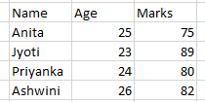

Step 2:
import pandas as pd

# Load the CSV file
data = pd.read_csv("C:/Users/student/Desktop/Students.csv")

# Display the data
print("Student Data:")
print(data)

# Find the mean of Marks
print("\nAverage Marks:")
print(data["Marks"].mean())

# Find the sum of Marks
print("\nTotal Marks:")
print(data["Marks"].sum())

# Filter students with Marks greater than 80
print("\nStudents with Marks greater than 80:")
print(data[data["Marks"] > 80])

Practical No.10
Aim: Plot bar chart and line chart using Matplotlib for a given dataset.
Theory:
Function Purpose
plt.bar() Draws a bar chart
plt.plot() Draws a line chart
plt.title() Adds a chart title
plt.xlabel() Labels the X-axis
plt.ylabel() Labels the Y-axis
plt.show() Displays the chart
Code:
import matplotlib.pyplot as plt

# Dataset
subjects = ["Math", "Science", "English", "Computer", "History"]
marks = [85, 90, 78, 95, 88]

# Bar Chart
plt.bar(subjects, marks)
plt.title("Student Marks - Bar Chart")
plt.xlabel("Subjects")
plt.ylabel("Marks")
plt.show()

# Line Chart
plt.plot(subjects, marks, marker='o')
plt.title("Student Marks - Line Chart")
plt.xlabel("Subjects")
plt.ylabel("Marks")
plt.show()

